**Project name: Employee Management System**

**Project scope:** The project aims to manage an employee's profile whereby the Admin can control the whole system and the employee can view all information related with his/her profile.

[Github link :](https://github.com/Gatera-Bosco/24416_Webtechnology_Final-Project/blob/main/src/main/java/rw/mis/employee/employeemanagamentsystem/controller/AdminController.java)

**Home Page:** contain with the Login option for Employee and the Admin

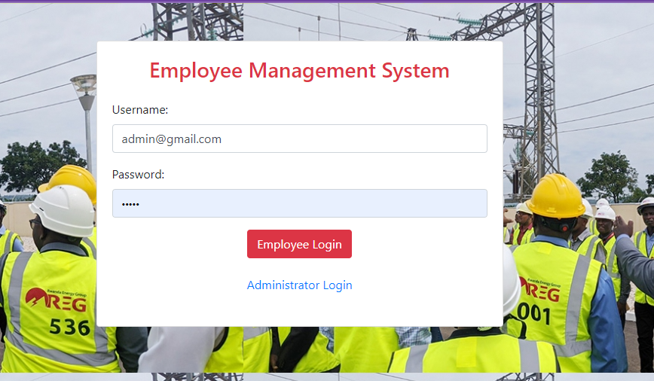

Admin credential has been created in the system and the Admin has all the privilege to managing the system - let us log as Admin.

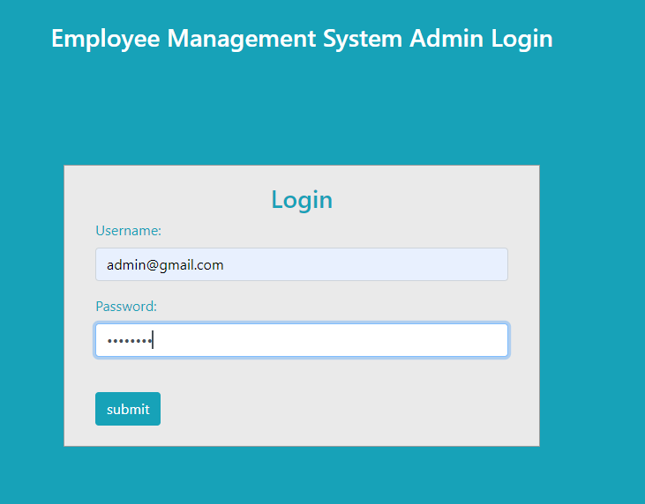

## 

## >>>Welcome to Employee Management System EMS Admin Dashboard

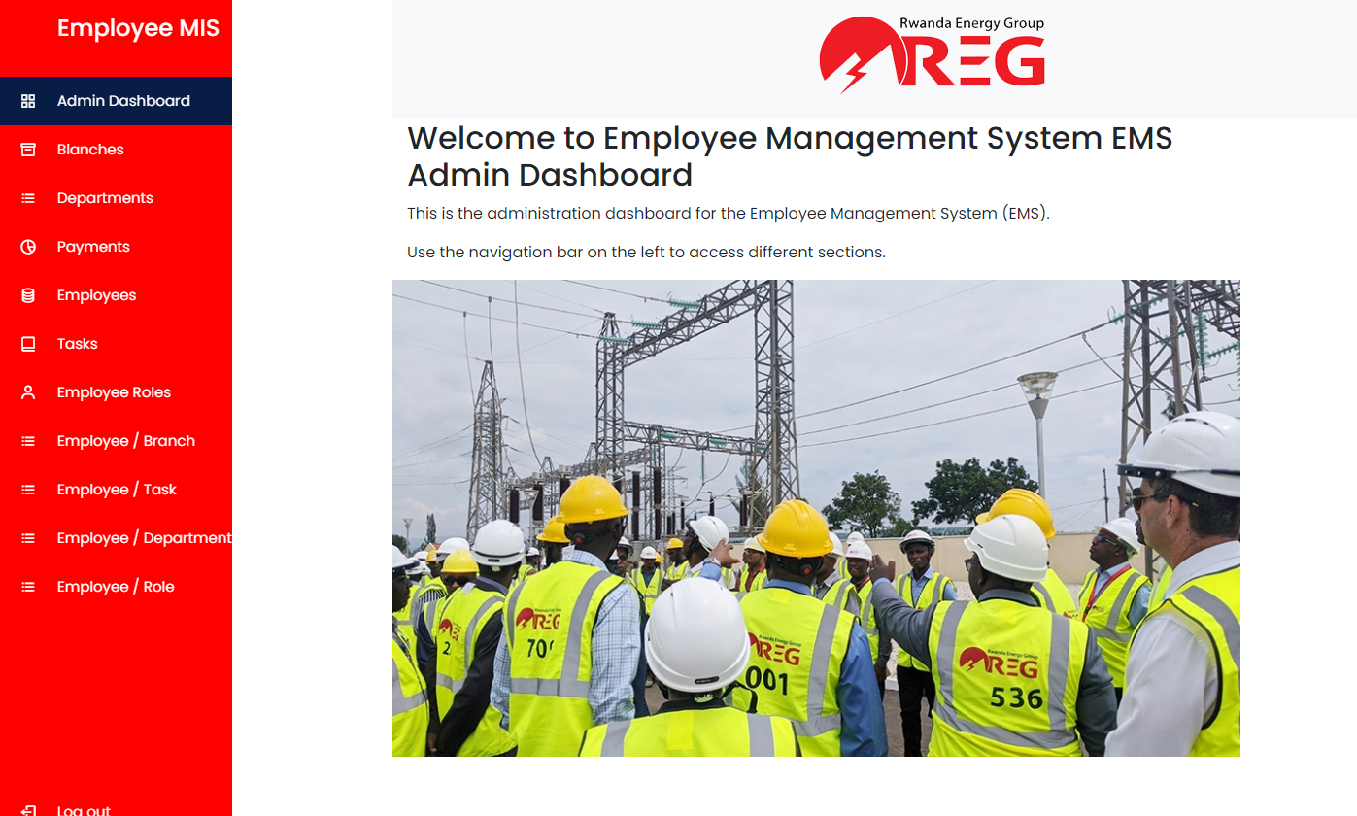

This is the administration dashboard for the Employee Management System (EMS).

Use the navigation bar on the left to access different sections.

>>>> **Let add new employee:** before add we need to add the Role, branches, department, so that we can know where the employee is located

Blanches

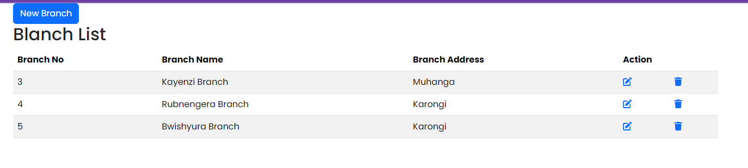

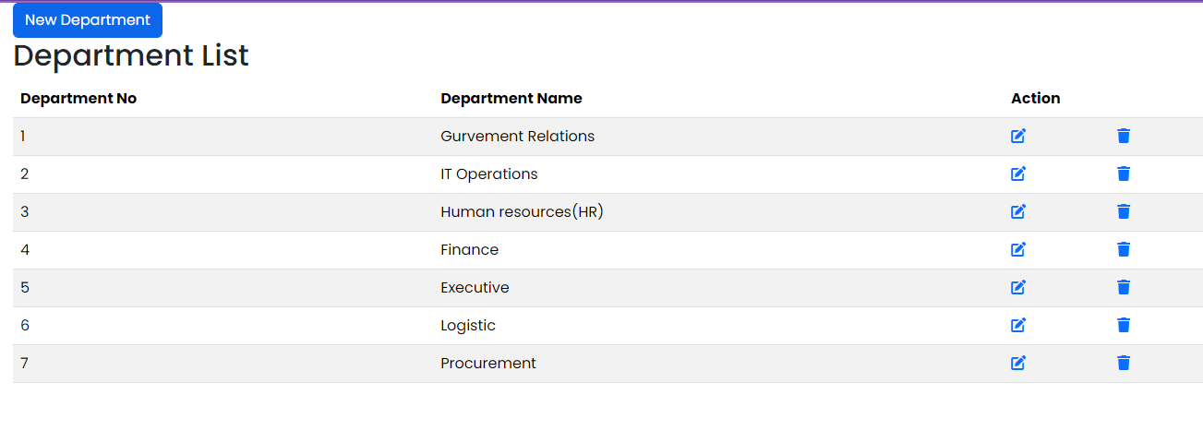

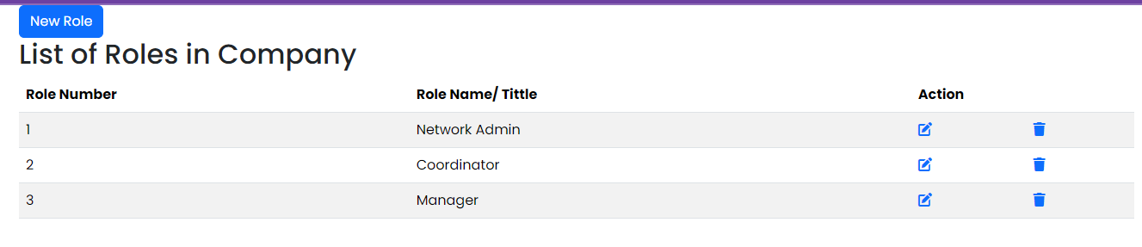

Adding a new Employee

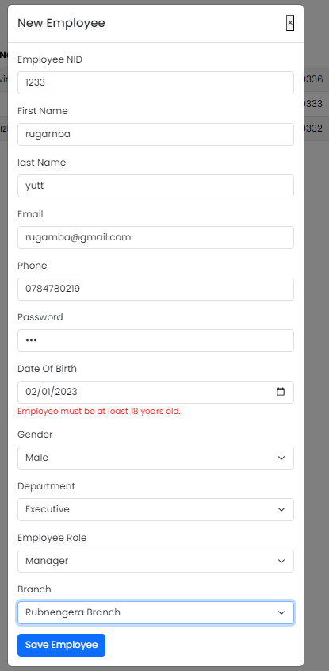

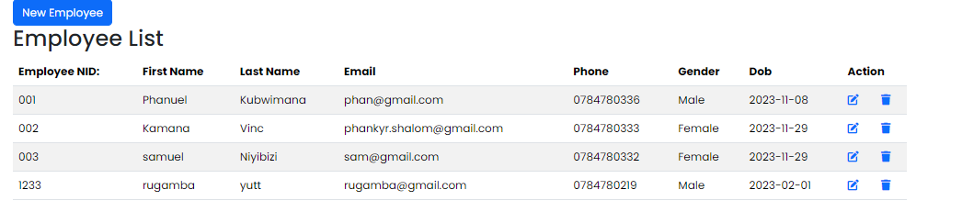

After Admin adding new employee, the admin can also assign task to the employee and the employee will get email notification about the new task has been assigned to him/her.

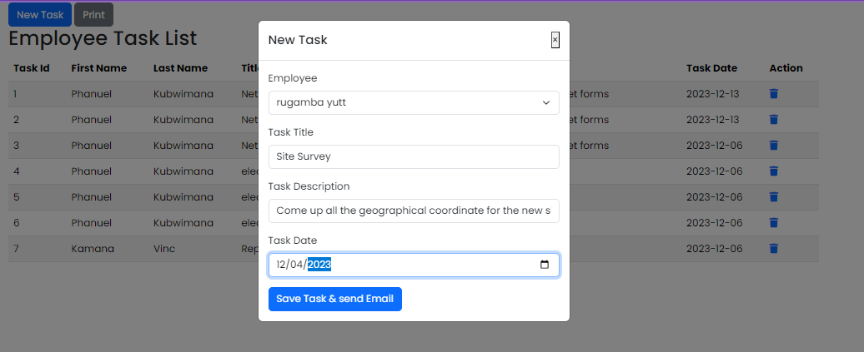

This how the email will look like

